Woodsville High School Silver Cord Program
Pre-Approval & Verification of Service Form
Use this form to verify service throughout the year and return no later than
May 15, 2020

Prior Approval to be filled out by the student and their Roundhouse Teacher.

Student Name________________________________________________________________________________

Graduation Year____________ Group or Organization________________________________________________

Proposed Activity & Description: _________________________________________________________________

____________________________________________________________________________________________

Estimated # of Hours: __________Start Date & Time____________________ End Date and Time______________

Total # of Hours: __________

I, ______________________________, pre-approve this activity. ______________________________ ________
Roundhouse Teacher’s Printed Name Roundhouse Teacher’s Signature Date

To be completed by the COMMUNITY MEMBER:

I verify that _________________________________________volunteered for ______________ hours.

During this time, _______________________________________ was not compensated in any way for the hours served and the service was not provided for a family member.

Group or Organization _________________________________________________________________________
(Hours completed with a school group may only count up to 50%)

__________________________________________ _________________________________________ ________
Community Member Name (print) Community Member Signature Date

___________________________________________________ __________________________________________________
Phone Number email address

Once this form has been completed, provide a copy of it, along with the Silver Cord Hours Completion Google Form, to the Dean of Students.

Silver Cord Hours Completion Google Form
https://docs.google.com/forms/d/1CJ2-GkETkr4UEjmlXqQPN7usCtm69x7Qwzm5dPbi4UE/edit

All hours need to be verified by sending a scan of your signed verification letter. You will also need to answer the following questions:
Please use complete sentences to answer the following statements:
- Write a brief description of what you did during this service activity.

- Describe what you gained from partaking in this volunteer service.

- How has this experience influenced your life and how were you helpful to others?

Your email should be sent to your Roundhouse Teacher, and the Subject should say Silver Cord Verification.
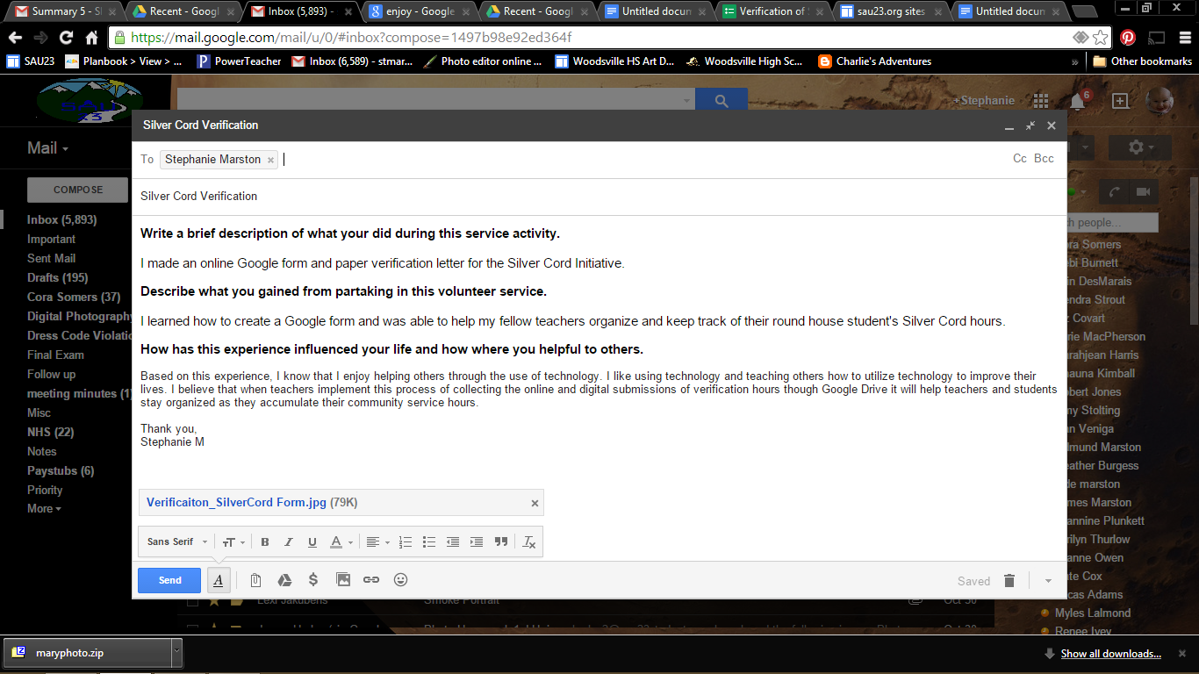
Below is a sample email:

